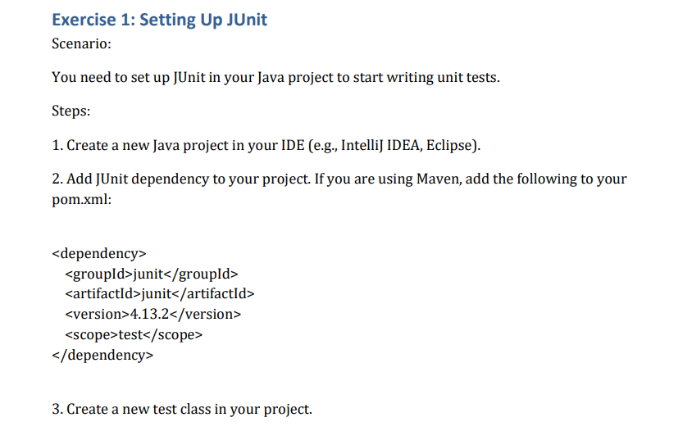

**Solution**

**Exercise 01:**

**Pom.xml:**

<project xmlns="http://maven.apache.org/POM/4.0.0"

xmlns:xsi="http://www.w3.org/2001/XMLSchema-instance"

xsi:schemaLocation="http://maven.apache.org/POM/4.0.0 https://maven.apache.org/xsd/maven-4.0.0.xsd">

<modelVersion>4.0.0</modelVersion>

<groupId>com.example</groupId>

<artifactId>JUnitBasicTestMaven</artifactId>

<version>0.0.1-SNAPSHOT</version>

<dependencies>

<dependency>

<groupId>junit</groupId>

<artifactId>junit</artifactId>

<version>4.13.2</version>

<scope>test</scope>

</dependency>

</dependencies>

</project>

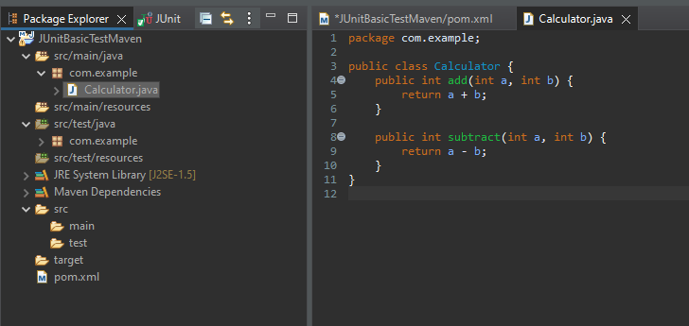

**Exercise 02:**

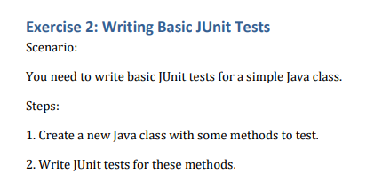

**Solution:**

**Calculator.java**

package com.example;

public class Calculator {

public int add(int a, int b) {

return a + b;

}

public int subtract(int a, int b) {

return a - b;

}

}

**CalculatorTest.java**

package com.example;

import static org.junit.Assert.*;

import org.junit.After;

import org.junit.AfterClass;

import org.junit.Before;

import org.junit.BeforeClass;

import org.junit.Test;

public class CalculatorTest {

@BeforeClass

public static void setUpBeforeClass() throws Exception {

}

@AfterClass

public static void tearDownAfterClass() throws Exception {

}

@Before

public void setUp() throws Exception {

}

@After

public void tearDown() throws Exception {

}

@Test

public void testAdd() {

Calculator calc = new Calculator();

assertEquals(5, calc.add(2, 3));

}

@Test

public void testSubtract() {

Calculator calc = new Calculator();

assertEquals(2, calc.subtract(5, 3));

}

}

**Output:**

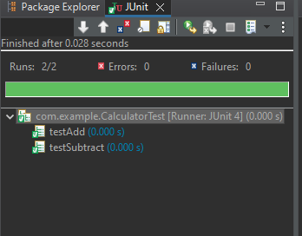

**Exercise 03:**

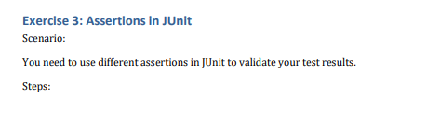

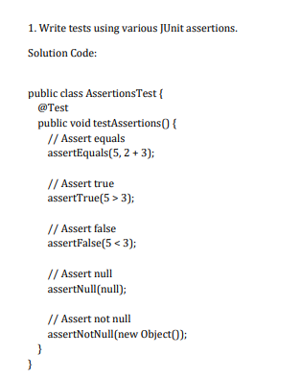

**Solution:**

**AssertionsTest.java**

package com.example;

import static org.junit.Assert.*;

import org.junit.Test;

public class AssertionsTest {

@Test

public void testAssertions() {

assertEquals(5, 2 + 3);

assertTrue(5 > 3);

assertFalse(5 < 3);

String s = null;

assertNull(s);

String str = "Hello";

assertNotNull(str);

}

}

**Output:**

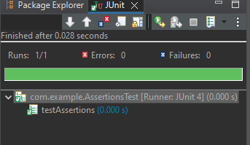

**Exercise 04:**

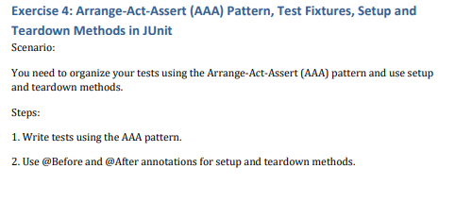

**Solution:**

**Updated CalculatorTest.java with Setup/Teardown:**

java

CopyEdit

package com.example;  
  
import static org.junit.Assert.*;  
import org.junit.*;  
  
public class CalculatorTest {  
  
 private Calculator calc;  
  
 @BeforeClass  
 public static void setUpBeforeClass() throws Exception {  
 System.out.println("Before all tests");  
 }  
  
 @AfterClass  
 public static void tearDownAfterClass() throws Exception {  
 System.out.println("After all tests");  
 }  
  
 @Before  
 public void setUp() throws Exception {  
 System.out.println("Before each test");  
 calc = new Calculator(); // Arrange  
 }  
  
 @After  
 public void tearDown() throws Exception {  
 System.out.println("After each test");  
 calc = null;  
 }  
  
 @Test  
 public void testAdd() {  
 int result = calc.add(2, 3);   
 assertEquals(5, result);   
 }  
  
 @Test  
 public void testSubtract() {  
 int result = calc.subtract(5, 3);   
 assertEquals(2, result);   
 }  
}

**Output:**

